**Lab 5**

1. **Data Import**

a.Download northwind-db.sql from classroom link

b.Open MySQL Workbench and Login using **root** or <name>

c.Create database <name>northwinddml

**Query:**create a database rajan_northwinddml;

**Output:**

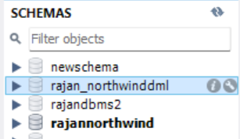

d.Import  downloaded database in <name>northwinddml

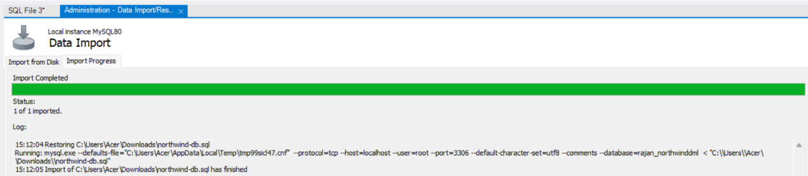

**Data MANIPULATION Languages (DML)**

**1.**Add two product categories of your choice

**Query:**

INSERT INTO categories (CategoryName, Description)

VALUES

('Electronics', 'Electronic devices and gadgets'),

('Books', 'All kinds of books');

**Output:**

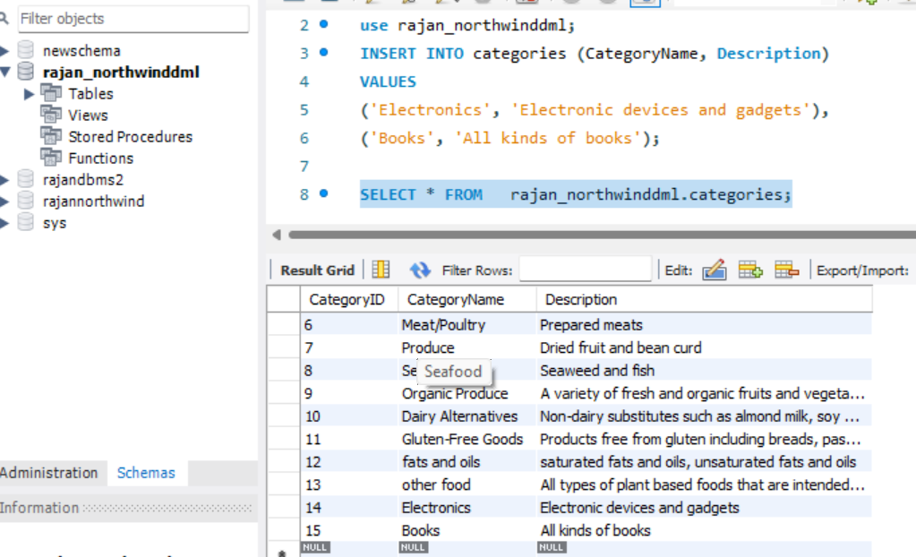

# Add 3 new suppliers in the suppliers table

**Query:**

INSERT INTO suppliers (SupplierName, ContactName, Address, City, PostalCode, Country, Phone)   
VALUES   
('Tech Supplies', 'Alice Johnson', '123 Tech Lane', 'Tech City', '12345', 'USA', '123-456-7890'),  
('Book Distributors', 'Bob Smith', '456 Book Blvd', 'Book Town', '67890', 'USA', '098-765-4321'),  
('Gadget World', 'Charlie Brown', '789 Gadget Rd', 'Gadget City', '54321', 'Canada', '456-123-7890');

**Output:**

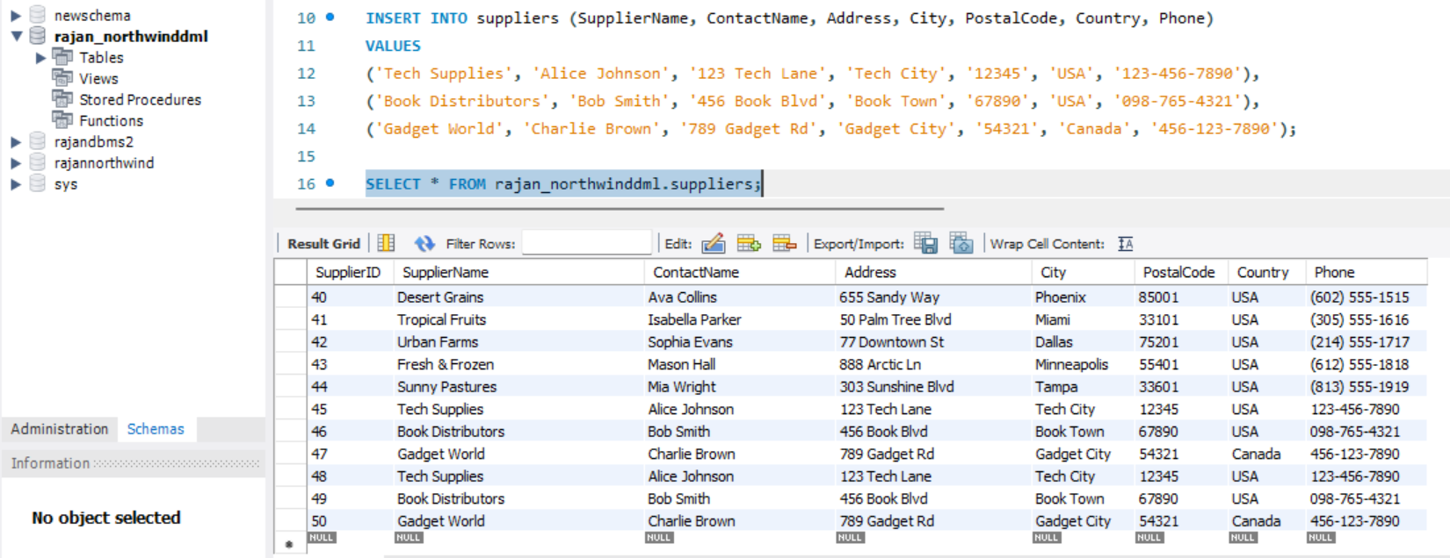

# 3.Add 5 new customers in the customers table

**Query:**

INSERT INTO customers (CustomerName, ContactName, Address, City, PostalCode, Country)   
VALUES   
('John Doe', 'John', '123 Main St', 'New York', '10001', 'USA'),  
('Jane Smith', 'Jane', '456 Elm St', 'Los Angeles', '90001', 'USA'),  
('Michael Johnson', 'Michael', '789 Oak St', 'Chicago', '60601', 'USA'),  
('Emily Davis', 'Emily', '101 Pine St', 'Houston', '77001', 'USA'),  
('David Wilson', 'David', '202 Maple St', 'Phoenix', '85001', 'USA');

**Output:**

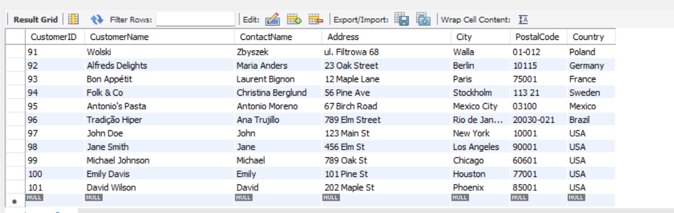

# 4.Add 4 products in the product table

**Query:**

INSERT INTO products (ProductName, SupplierID, CategoryID, Unit, Price)   
VALUES   
('Smartphone', 1, 1, 'Piece', 699),  
('Laptop', 1, 1, 'Piece', 999),  
('Fiction Book', 2, 2, 'Piece', 20),  
('Non-fiction Book', 2, 2, 'Piece', 25);

**Output:**

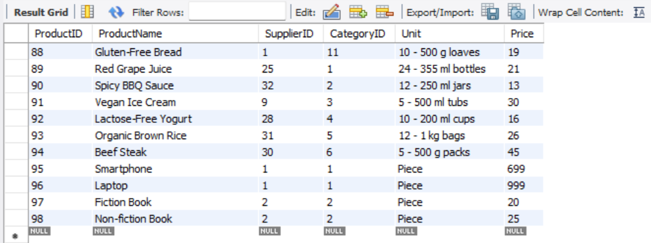

# Add 3 new employees

**Query:**

INSERT INTO employees (LastName, FirstName, BirthDate, Photo, Notes)   
VALUES   
('Anderson', 'Mark', '1980-05-15', 'mark.jpg', 'Notes about Mark'),  
('Taylor', 'Laura', '1985-07-20', 'laura.jpg', 'Notes about Laura'),  
('Brown', 'Chris', '1990-08-25', 'chris.jpg', 'Notes about Chris');

**Output:**

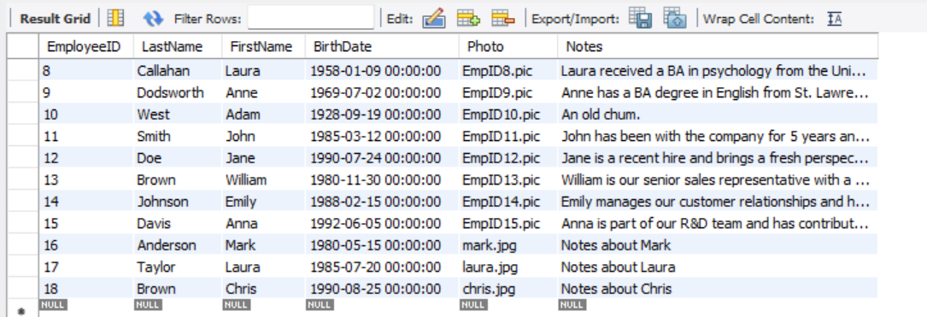

1. Update all customers from Brazil to Singapore

**Query:**

SET SQL_SAFE_UPDATES = 0;

UPDATE customers

SET Country = ‘Singapore’

WHERE Country = 'Brazil';

SET SQL_SAFE_UPDATES = 1; -- Re-enable safe update mode

**Output:**

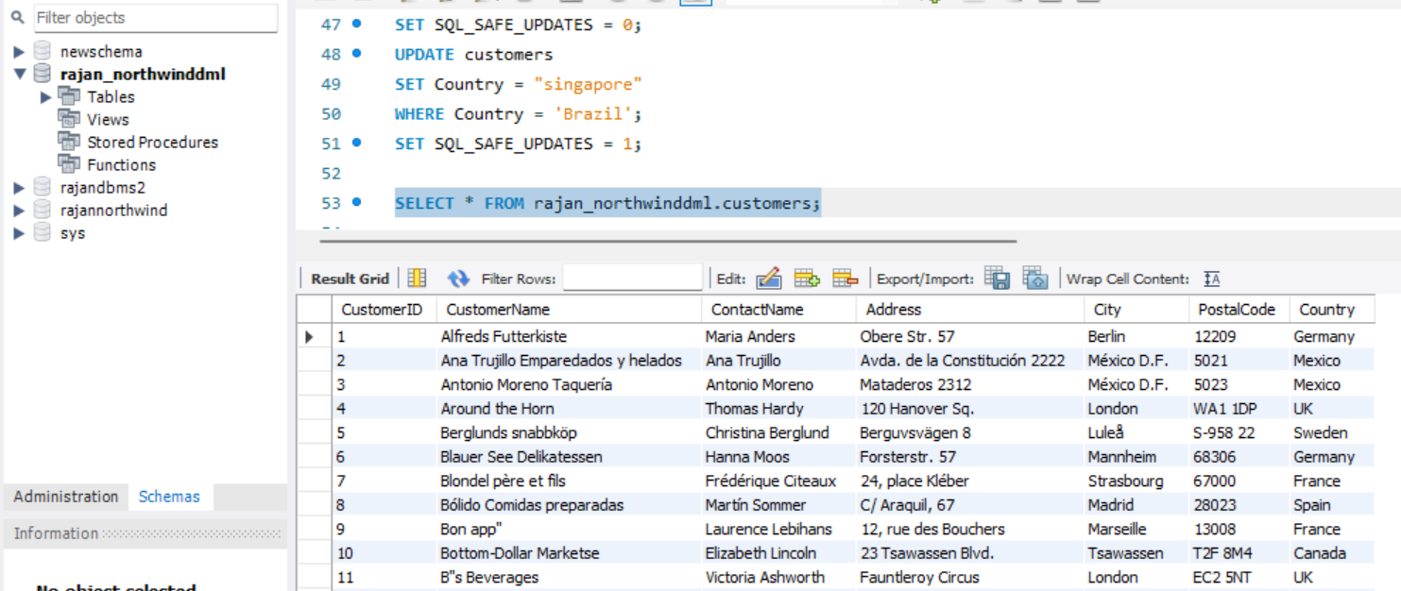

1. Update customers table changing name of Madrid City to Bangalore

**Query:**

UPDATE customers SET City = 'Bangalore' WHERE City = 'Madrid City';

Output: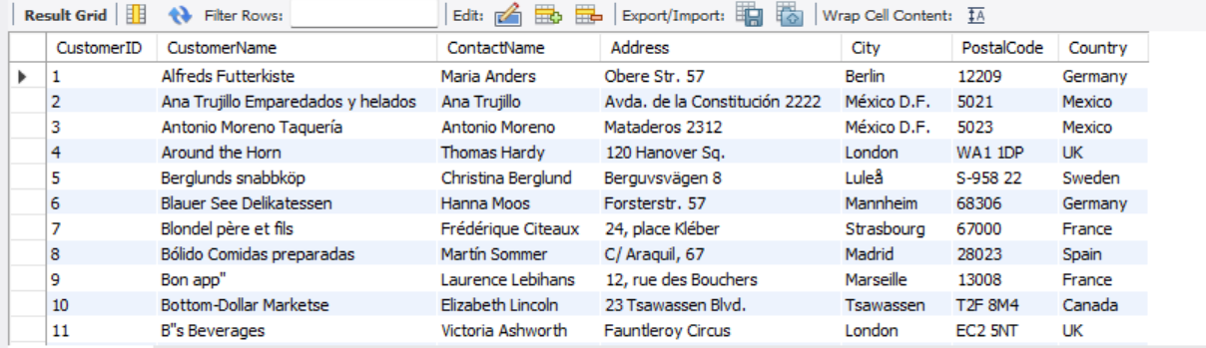

1. Update all German customer to Bhutanese customers

**Query:**

UPDATE customers SET Country = 'Bhutanese' WHERE Country = 'German';

**Output:**

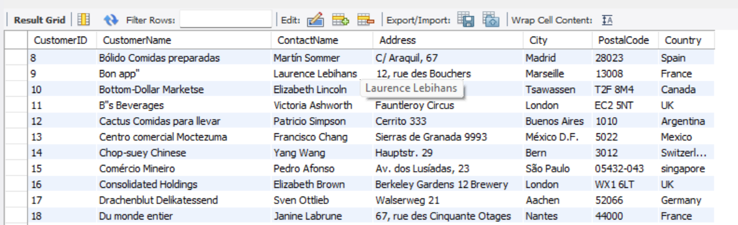

1. Convert all Spanish customer to Thai Customers

**Query:**UPDATE customers SET Country = 'Thai' WHERE Country = 'Spanish';

**Output:**

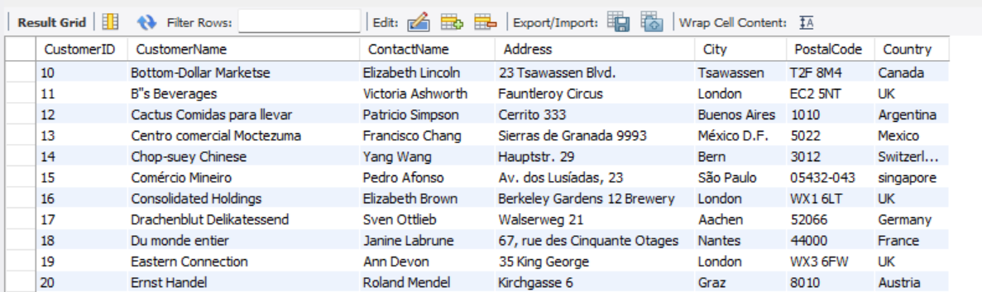

1. Convert all customers of London to Kathmandu customers also change name of country

**Query:**

UPDATE customers SET City = 'Kathmandu', Country = 'Nepal' WHERE City = 'London';

**Output:**

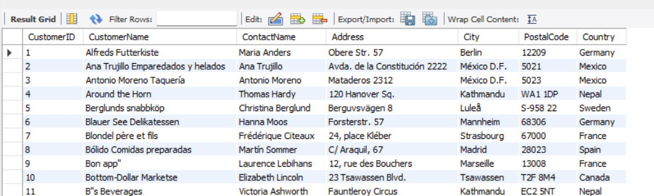

11.Convert customers from G7 Countries to SAARC Countries

**Query:**

UPDATE customers SET Country = 'SAARC Country' WHERE Country IN ('USA', 'Canada', 'UK', 'France', 'Germany', 'Italy', 'Japan');

**Output:**

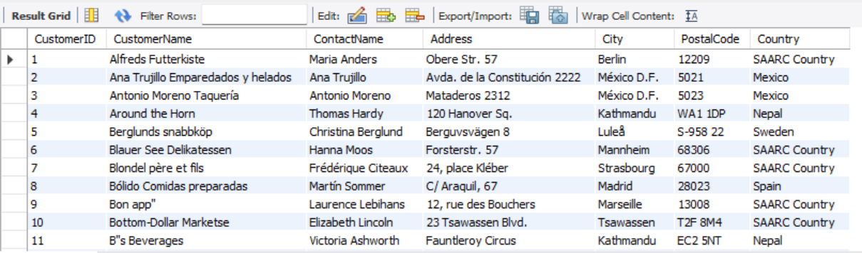

# 12.DELETE all from customers who have PostalCode containing 31

**Query:**

DELETE FROM orderdetails WHERE OrderID IN (SELECT OrderID FROM orders WHERE CustomerID IN (SELECT CustomerID FROM customers WHERE PostalCode LIKE '%31%'));

DELETE FROM orders WHERE CustomerID IN (SELECT CustomerID FROM customers WHERE PostalCode LIKE '%31%');

DELETE FROM customers

WHERE PostalCode LIKE '%31%';

**Output:**

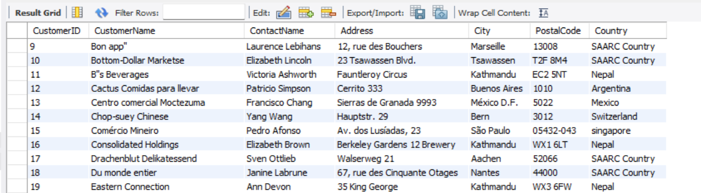

# DELETE all from customers having PostalCode containing 00 and from Rome or Paris

**Query:**

DELETE FROM customers WHERE PostalCode LIKE '%00%' AND City IN ('Rome', 'Paris');

Output:

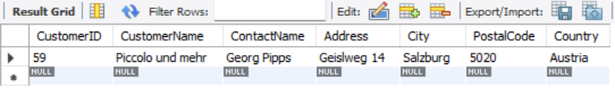

# DELETE all from customers who are not from Salzburg

**Query:**

DELETE FROM customers

WHERE PostalCode LIKE '%31%';

SELECT * FROM sandip_northwinddml.customers;

DELETE FROM orderdetails

WHERE OrderID IN (SELECT OrderID FROM orders WHERE CustomerID IN

(SELECT CustomerID FROM customers WHERE City != 'Salzburg'));

DELETE FROM orders

WHERE CustomerID IN (SELECT CustomerID FROM customers WHERE City != 'Salzburg');

DELETE FROM customers

WHERE City != 'Salzburg';

**Output:**

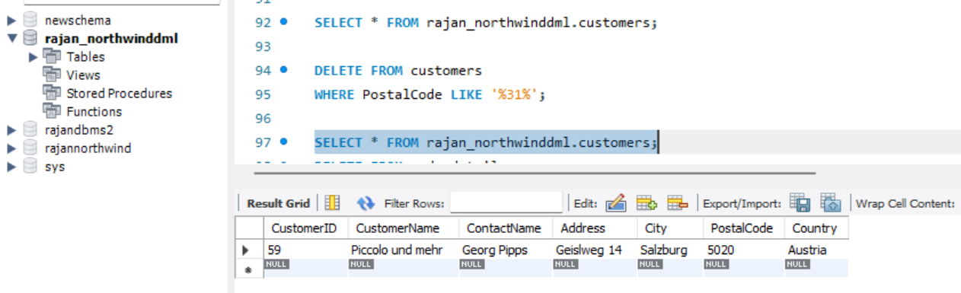

# DELETE all employees who are born in July

**Query:**DELETE FROM employees WHERE MONTH(BirthDate) = 7;

**Output:**

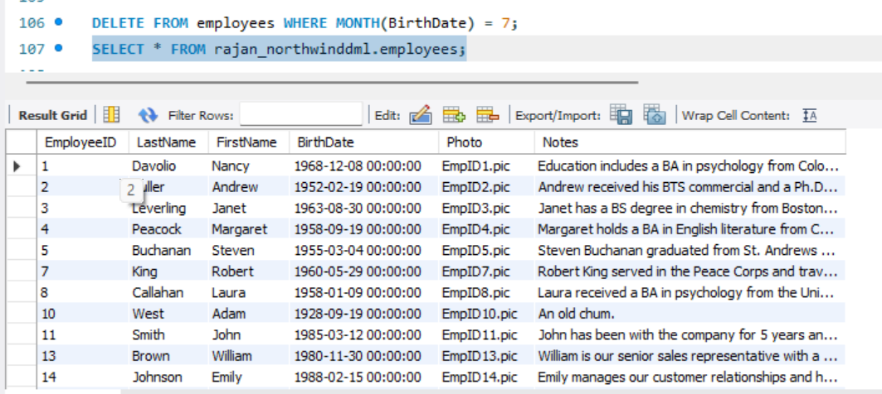

# DELETE all employees who are born in August

**Query:**

DELETE FROM employees WHERE MONTH(BirthDate) = 8;

**Output:**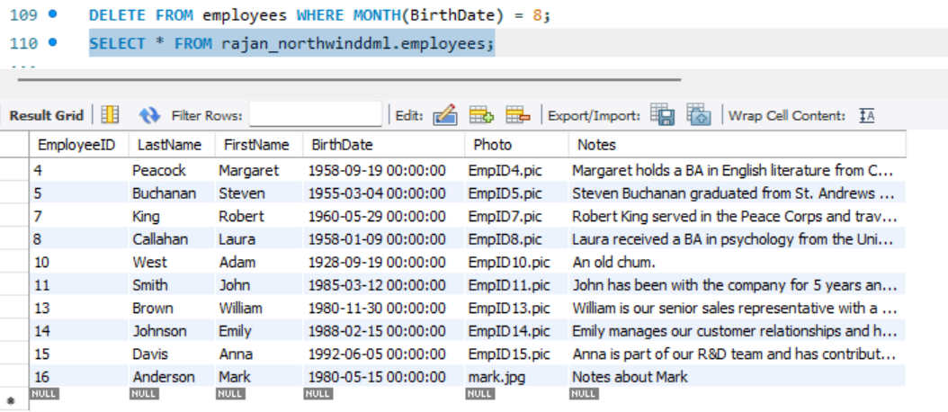

# DELETE all suppliers from Singapore and Japan

**Query:**

DELETE FROM orderdetails

WHERE ProductID IN (SELECT ProductID FROM products WHERE SupplierID IN

(SELECT SupplierID FROM suppliers WHERE Country IN ('Singapore', 'Japan')));

DELETE FROM products

WHERE SupplierID IN (SELECT SupplierID FROM suppliers WHERE Country IN ('Singapore', 'Japan'));

DELETE FROM suppliers

WHERE Country IN ('Singapore', 'Japan');

**Output:**

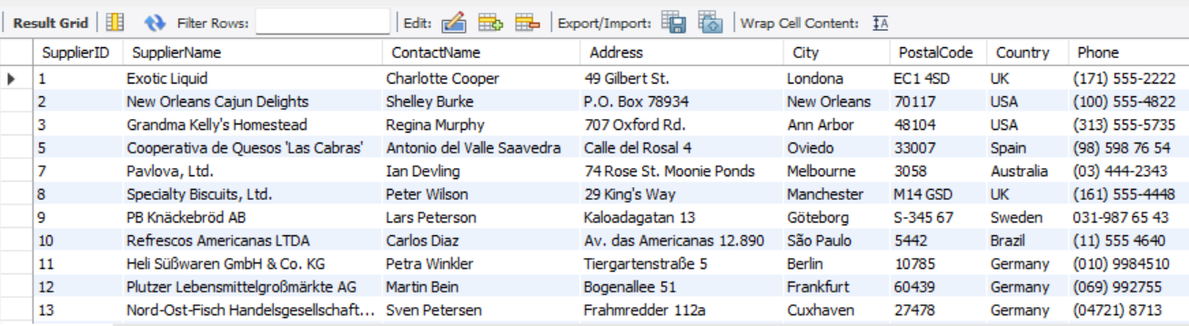

# 18.Find the name and count of suppliers from different countries

**Query:**SELECT Country, COUNT(SupplierID) AS SupplierCount   
FROM suppliers GROUP BY Country;

**Output:**

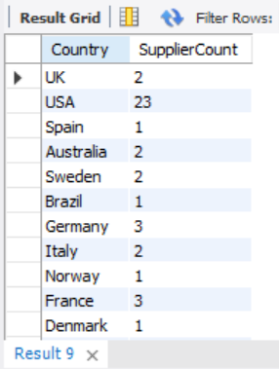

# 19.Find the name and count of customers from different cities

**Query:**

SELECT City, COUNT(CustomerID) AS CustomerCount   
FROM customers GROUP BY City;

Output:

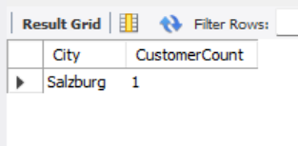

# 20.Find the number of orders made by employees along with EmployeeID

**Query:**

SELECT EmployeeID, COUNT(OrderID) AS OrderCount   
FROM orders GROUP BY EmployeeID;

**Output:**

